MAY 2021
MONTHLY REPORT

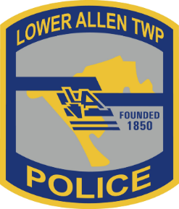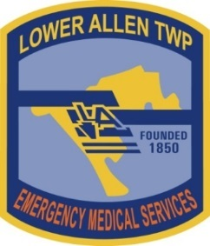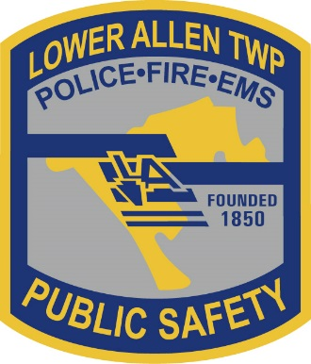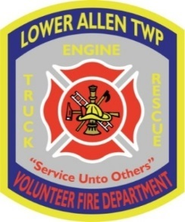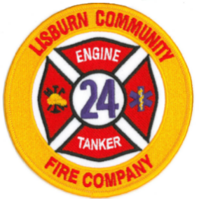
Lower Allen Township is currently accepting qualified applicants for:

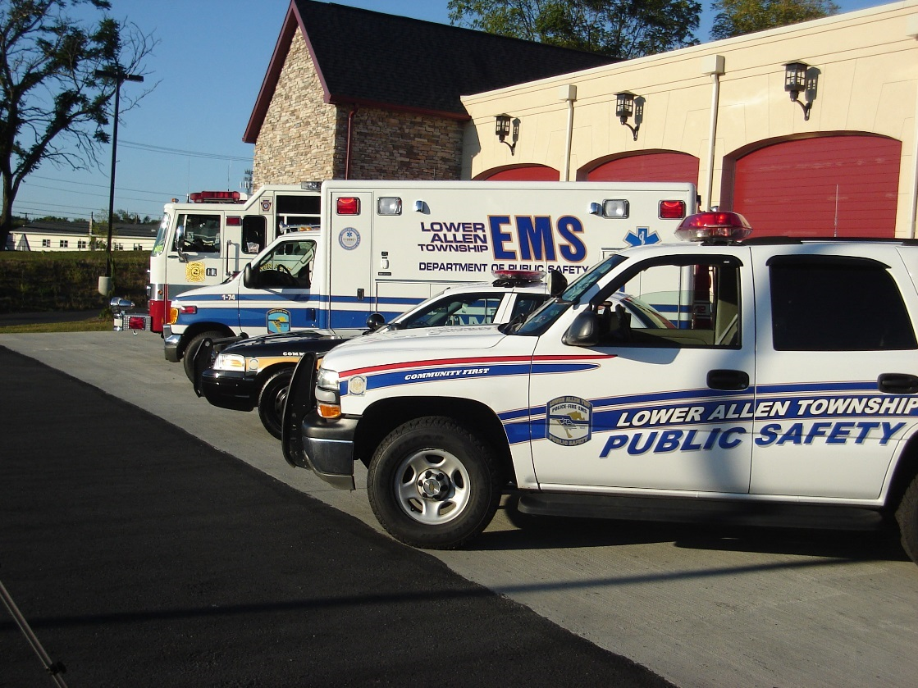

TABLE OF CONTENTS
MAY 2021

Director Page 3

Police Captain Pages 4-9

Support Services Lieutenant Pages 10-15

Police Operational Services Lieutenant Pages 16-20

EMS Pages 21-28

Fire Captain (Fire/PSOs) Pages 29-31

DPS – MAY 2021
Director David L. Holl

During May, the COVID-19 pandemic practices began transition and continued to be less impactful to public safety operations. In most area of public safety, we were very close to 100% full vaccinations by the end of the month. Captains continued to keep in contact with staff and assisted in coordination of this effort. Throughout the COVID pandemic we were proud to achieve NO cases of COVID-19 among staff contracted as a part of their job responsibilities. We attribute this largely to the diligence in policy and procedures, and a dedicated diligence in safeguarding citizens we contacted and each other. As case counts decline, I continued to follow the statewide statistics on the Department of Health dashboard.

Much of my time, as Director and Emergency Management Coordinator, continued to focus on monitoring the public safety preparedness and response to the potential virus impact to the employees and the Lower Allen Community. I also monitored the PEMA, FEMA, and county EMA releases daily. Public Safety Planner Strawser and I continued to meet via TEAMs as he works on various annex plans to our EOP.
The highlights of May included:

May 4th – Attended a webinar titled “Future-Proofing Policing: An Intelligence-led Approach to Crime, Resourcing, and Decision Making.”

May 6th – Attended an FBI National Academy training webinar titled “Rebuilding Communities: Strategies for Today and Tomorrow”.

May 10th - Provided welcoming and opening comments for the Cumberland County Crisis Intervention Team training sponsored by Cumberland County Mental Health at the Lower Allen Barn. This was a weeklong (40 Hr.) course for police officers to be trained on recognition of mental health issues in police contacts and appropriate intervention. Lower Allen PD has three officers attend this training. Additional classes are planned in the future.
May 25th – Captain Deaven and I conference with “DisposeRx” as we continue to look at unused drug disposal options for Bethany as well as the community in general.

Attended numerous meetings throughout the month including Board of Commissioners, department head, Chiefs of Police, EMS Council, and staff meetings, and alarm standards meetings for the AVS-01 TMA ANSI standard development.

Respectfully Submitted,
David L Holl
Director, Department of Public Safety

POLICE – MAY 2021

Captain Leon Crone

DEPARTMENT HEAD:

May saw some exciting developments. The body-worn camera project began its culmination with the installation of hardware and the roll-out of devices for use. Lt. Sentman and Technician Ickler bore the lions-share of implementation, working with a manufacturer’s representative to ensure as smooth a technical transition as possible.

Officer Lightner has completed field training and is now operating on patrol. With that change, we were able to re-establish a flex-officer position to assist our criminal investigations office. Officer Cramer will be assuming these duties until we reach full staffing.

Throughout the month, Captain Crone attended Police Command Staff meetings, a Police Department Supervisors’ meeting, Board of Commissioners Meetings, Department Head Meetings, a County Chiefs’ meeting, a Central Chiefs’ meeting, range training, a Public Safety Captains’ meeting, and various personnel-related meetings. Captain Crone also accompanied other public safety staff on a walk-through of the new Rossmoyne Elementary School.

The CALEA Annual Compliance Check was concluded, with the agency found to be in ongoing compliance with the standards that were examined.

Background checks on police candidates are ongoing. As we move through the list, some candidates were eliminated while others accepted job offers elsewhere. We continue to work through the list.

Captain Crone and Julie Echterling continue to prepare for the CALEA Annual Compliance Check, which begin April 30th. As of this writing, that assessment has concluded and preparation for year four of the cycle continued.

Congratulations to the May officer of the month, Michael Lightner. Officer Lightner was recently released from field training and has hit the ground running. He is following up on cases exhausting all leads or making arrests. He completed substantial follow up in a stolen wallet/ credit card case, linking it to a similar crime in Springettsbury Township. This includes obtaining video from every business where the card was used. He also assisted the Attorney General’s office with a search warrant resulting in recovery of drugs. He was able to follow leads for a stolen phone and successfully recover the phone and charge the suspect involved. In all, Officer Lightner handled 10 UCR cases and was able to close 4 with arrests. He handled 37 calls for service.

On May 20, 2021, he assisted in a roll over crash, where he applied a tourniquet to a patient that was seriously bleeding from the arm. The hospital later advised it was an arterial bleed requiring immediate surgery and the application of the tourniquet likely was a life-saving action. Ofc Lightner is utilizing his experience and skills as a certified EMT.

NALOXONE
There was no Naloxone administration by police personnel in Lower Allen Township this month.

POLICE – MAY 2021

Captain Leon Crone

UCR Crime Statistics

May

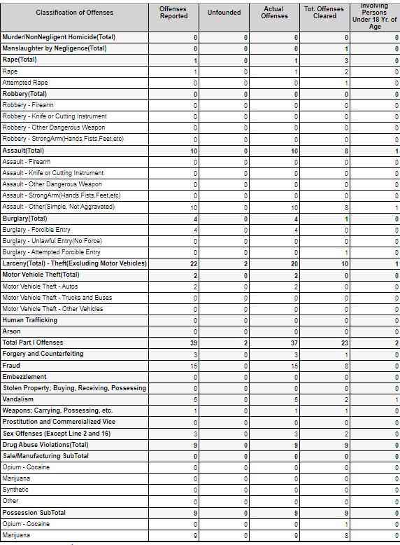
POLICE – MAY 2021

Captain Leon Crone

ARRESTS:
These are the charges for which arrests have been made in the month of May.

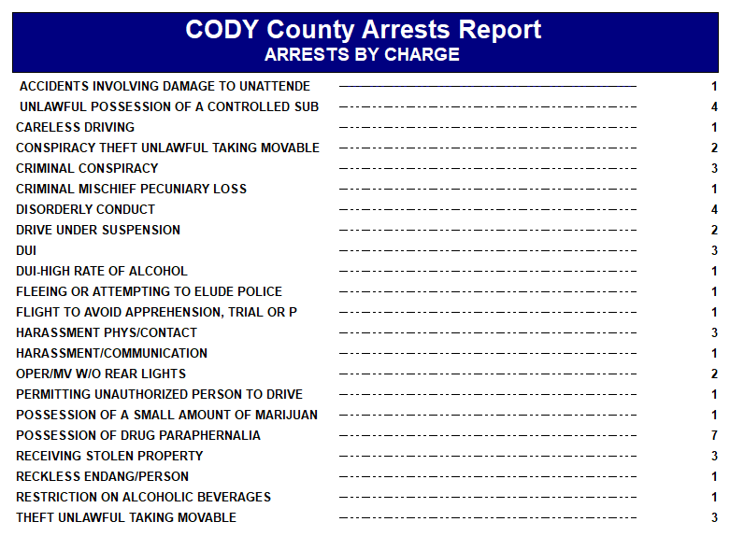

POLICE – MAY 2021

Captain Leon Crone

MONTHLY TOP 40 INCIDENT COUNT BY TYPE and SELECTED OFFICER LOG FIGURES

The most recent month figures are presented first, followed by last year’s figures. In lieu of the multi-page listing, the two Top-40 charts were used. This, coupled with the monthly totals in other charts, creates a more succinct picture of police department activity. The Selected Officer Log Figures chart that follows the Incident Count charts are items that consume patrol resources but are not documented in incident reports.

2021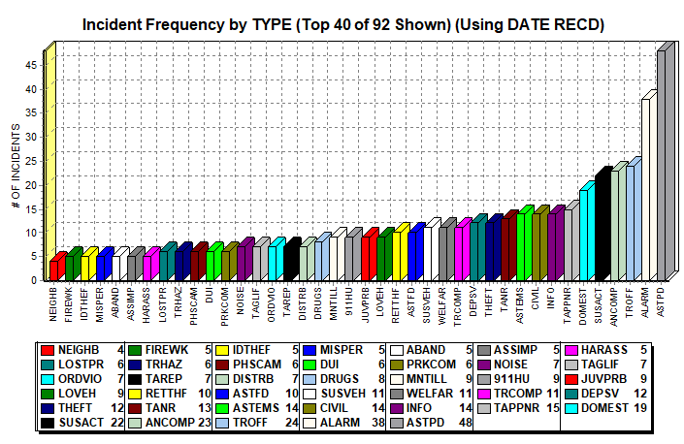

POLICE – MAY 2021

Captain Leon Crone

2020
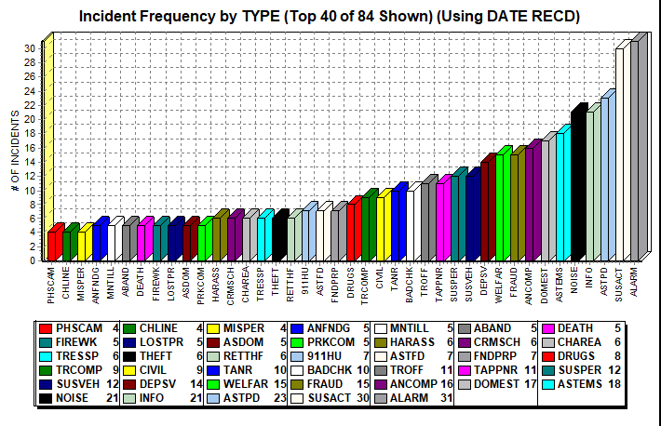

POLICE – MAY 2021

Captain Leon Crone

RECORDS FUNCTION:
Records staff continues the normal daily routine of organizing, filing, and distributing paperwork as appropriate, as well as fielding calls for service over the phone and handling or directing walk-up customers (though rare, due to the building closure). Previous month’s numbers included for comparison.

MAY:

RTK/Report Disseminations - 27

Warning/Citation Entries - 355

Case Folders Created - 105

Complaints Reviewed - 566

Arrest Reports Entered/Filed – 54

APRIL:

RTK/Report Disseminations - 23

Warning/Citation Entries - 249

Case Folders Created - 90

Complaints Reviewed - 523

Arrest Reports Entered/Filed – 49

Respectfully submitted,
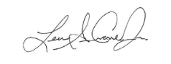
Capt. Leon G. Crone, Jr., Police Captain

COMMANDER:
POLICE – MAY 2021
Support Services Bureau
Lt. Donald Sentman

Here is a list of activities I attended or performed in addition to my normal responsibilities.
Continued Training with Corporal Scarlato to take over as CI Corporal.
Ordered/ Equipped and fitted all officers for Riot gear. Process is continuing. Received majority of the gear in house and have equipped those who may have been deployed to potential scenes. Waiting on a few more items to equip the entire department.
Participated in Oral interviews for potential Community Service Officer applicants. Scored oral interviews with Captain Crone and Donna Paul.
Worked with Technician Ickler to repair/replace equipment in patrol vehicles to include Watchguard Video equipment and minor radio issues.
Began process of inventory for all major equipment. Started with portable radio documentation.
Started training process for all sworn officers as well as Community Service officers on functions of and use of prisoner transport van. Process completed with all offices being trained.
Arranged for CPR/First Aid Training for Officer Fitzkee
Began process with D. Knisley for ordering replacement vests for officers with vests that expire in 2021. Prepare list for potential orders in 2022. Process included assistance with Grant funding information and preparation.
Started the process of rolling out and implementing Body Worn Cameras (BWC), to all officers. This included the process of assisting Tech. Ickler and WATCHGUARD staff in updating the current server and loading all new software on server. Officers assigned a BWC and all shown the way to deploy it. Assisted officers in getting it fitted properly on their vests and the proper use.
Assisted Lt. Foltz with the appointment of Kevin Cramer as the new “flex officer” position.
Activated training in Power DMS for BWC policy/test created by Captain Crone.
Prepared for release training/exam in Power DMS for Use of Force to release in late summer early fall.
Started preparation and planning to move all Quartermaster Data to PLANIT for better use of records management.
Placed orders for replacement ballistic vests for officers who were due.
Notified Dr. Lou Laguna of pending department hires and secured possible dates for appointments.
Second yearly evidence room inspection was completed with no issues found.
DEPT. TRAINING The department had training for Body Worn Cameras (BWC), during the month of May. All officers, save Detective McNair, were shown the camera and trained on the proper use of said cameras.
POLICE – MAY 2021
Support Services Bureau
Lt. Donald Sentman

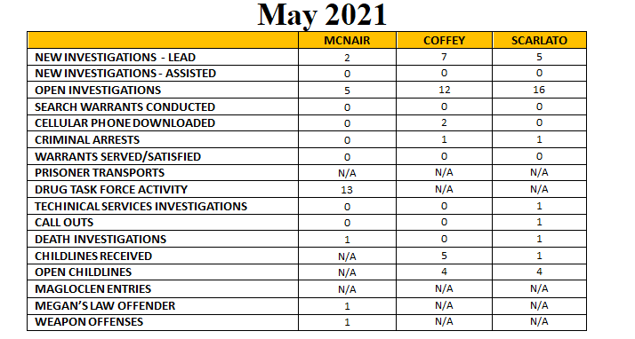Arrest Summaries (Min: Investigator, Accused, Adult/Juv, Location, Crime):
Detective Corporal Scarlato arrested a 34 YOA B / F for Access Device Fraud and other related charges stemming from a purse theft from BJ’s Wholesale Club. This individual was involved in several similar incidents in surrounding jurisdictions and lead to the closure of several open cases.
Detective Coffey arrested a 39 YOA W / M for Drug Delivery Resulting in Death for the 2019 overdose death of a male victim.
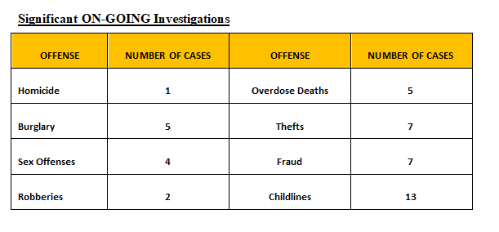
POLICE – MAY 2021
Support Services Bureau
Lt. Donald Sentman

Other Significant Activity:
On May 24th, Officer Cramer was assigned to the specialized position of Flex Officer and was reassigned to supplement the Criminal Investigations Office.
Training:
No pertinent training was attended during the month of May
Photo Downloads: 39
Evidence Custodian:
- 05/03/21 Certified Letter Returned – “Unable to Forward” LA-18-01996
- 05/04/21 Property Return to Owner – Cash LA-21-01907
- 05/04/21 MVR Request CCDA Jennifer Peitz DUI LA-20-05649
- 05/04/21 MVR Request CCDA Jennifer Peitz DUI LA-21-00384
- 05/04/21 MVR Request CCDA Jennifer Peitz DUI LA-20-05868
- 05/04/21 MVR Request CCDA Jennifer Peitz DUI LA-20-05895
- 05/04/21 Video Request CCDA Retail Theft LA-21-00320 1820
- 05/04/21 Video Request CCDA Traffic LA-21-00016 1820
- 05/04/21 Copy thumb drive 1820 LA-21-01947 Phone Download
- 05/04/21 Evidence Request PLH 1823 LA-20-06398
- 05/04/21 Evidence Request PLH 1812 LA-21-00658
- 05/06/21 Evidence Request PLH 1826 LA-20-04558
- 05/13/21 Evidence Request CCC 1814 LA-20-05050
- 05/14/21 MVR Request 1820 PLH Traffic Stop LA3 15:53:49 LA-21-02165
- 05/14/21 MVR Request 1820 PLH Traffic Stop LA4 15:54:06 LA-21-02165
- 05/14/21 CALEA Request – Copy of WatchGuard Event Log – Julie
- 05/14/21 CALEA Request – Copy of WatchGuard MVR Request - Julie
- 05/20/21 MVR Request CCDA Jennifer Peitz DUI LA-21-00796
- 05/20/21 MVR Request CCDA Jennifer Peitz DUI LA-20-05568
- 05/20/21 MVR Request CCDA Jennifer Peitz DUI LA-21-00770
- 05/20/21 MVR Request CCDA Jennifer Peitz DUI LA-21-00969
- 05/24/21 Video Evidence Request 1820 LA-21-02165
- 05/26/21 Photo Request CCDA Tracy White 1816 LA-20-04161

Evidence Technician:
POLICE – MAY 2021
Support Services Bureau
Lt. Donald Sentman

- 05/01/21 Call Out – 1225 Rossmoyne Rd. – theft of metal Rossmoyne Elem, School
- 05/05/21 Process evidence – five (5) sheets of metal siding & return to victim
- 05/06/21 Class – Vehicle Systems Forensics – Death Scene Awareness Project – Hbg., PA
- 05/07/21 Search Warrant – 137 Lancaster Blvd. LA-21-02127
- 05/13/21 Call Out – 2880 Gettysburg Rd. Death investigation LA-21-02222
- 05/17/21 Call Out – 3435 Simpson Ferry Rd. Burglary LA-21-02317
- 05/24/21 Call Out – 2100 Cedar Run Dr. Death Investigation LA-21-02453
- 05/26/21 Photograph Assault victim 1828 LA-21-02469
- 05/29/21 Call Out – LATPD Impound Process Recovered Stolen Vehicle LA-21-02534
Vehicle Maintenance:
- 05/03/21 Car 04 LATPD – replaced WatchGuard wireless microphone – ordered replacement microphone (CS-382536-W1L5 WD:0038279676)
- 05/03/21 Car 05 LATPD – replaced DVR – new unit would not shut down
- 05/03/21 Car 07 LATPD – replaced bad two-way radio microphone Harris MC-101616- 041 Rev A
- 05/03/21 Rabold’s – Speed Timing Devices Certification
- 05/06/21 Car 02 Twp. Garage - serviced
- 05/07/21 Car 03 Twp. Garage - serviced
- 05/11/21 Car 07 Moyer Communications – Tx problem – no problem found
- 05/11/21 Car 16 Twp. Garage – State Inspection
- 05/17/21 Car 07 Moyer Communications – Align Radio
- 05/17/21 Car 16 Township Garage – repair broken motor mount and windshield wiper hose
- 05/27/21 Car 07 Township Garage – service
- 05/27/21 Car 04 LATPD – WG replaced full USB in DVR – not transferring video

POLICE – MAY 2021
Support Services Bureau
Lt. Donald Sentman

Certified Letters Sent – Property Return | 0
Crime Scene Call Out | 5
COG Sale – Bicycles | 0
Court Dispositions | 14
Drug Destruction | 0
Evidence Delivered to AG's Office | 0
Evidence Delivered to Cumb Co DA | 11
Cases Delivered to Cumb County Lab | 4
Cases Delivered to PSP Lab | 4
Evidence for Cumberland County Court | 1
Evidence for Preliminary Hearing | 5
Evidence Picked up from AG's Office | 0
Evidence Picked up from CC Lab | 2
Evidence Picked up from PSP Lab | 6
Evidence Processing | 0
Evidence, Cases Purged from Evid Room | 1
Evidence /Property Returned to Owner | 1
Evidence Room Inspection | 1
Evidence Requested for Review by Officer | 0
Evidence Sent to U.S.S.S. | 0
Expungement Orders | 6
Gun Destruction | 0
Latent Print Cases | 0
New Cases Submitted into Evidence Room | 43
Property Disposition Forms Returned | 0
Property Disposition Forms Sent | 0
Requests for DVD | 14
Requests for Photographs | 2
Unclaimed Property to State UCP | 0
Items Entered into Evidence Room | 201
Items Removed from Evidence Room | 1
Supplemental Reports | 11
Assist Outside Agencies – Forensics | 0
Rx Drug Turned into County Lab – Destruction | 0
PA State Police PICS Checks | 1
PA State Police PICS Checks – Denials | 0
Fingerprint Applicant | 0
CODY IRF | 0
Quartermaster Requests | 6
Vehicle Maintenance Requests | 12
Total Requests | 3546
Evidence Room Item Count | 3822
POLICE – MAY 2021
Support Services Bureau
Lt. Donald Sentman

Quartermaster:
- 05/03/21 Received order from Galls – 6 ea. Riot Stick Ring Holders – 20 on backorder
- 05/06/21 Had six keys made for Quartermaster cage lock
- 05/07/21 Received order from Gall’s – 26 Riot Sticks
- 05/07/21 Received order from Galls – shin pads
- 05/07/21 Officer Walters’s uniform & equipment turn in – resignation
- 05/26/21 Officer Stirling – replacement earpiece tube
Projects:
- Assisted Scot Emerson with installation of new CCTV Equipment
- Assisted Scot Emerson with the installation of WatchGuard Server – third floor server closet – Bob Hamsher cleaned floor of closet
- Implementation of BWC System
CSO PROGRAM
The Community Service Officers covered 78 hours of street shifts each week. They also covered traffic control details at CLA and Christ Community Church each Sunday morning. This Resulted in 209 Street hours covered and 42 Detail Hours Covered by Community Service Officers during the month. Two (2) Barn details were covered in addition the street hours and church service hours provided by the CSO Program.

Respectfully submitted,

Lt. DJ Sentman 1804
Bureau Commander of Support Services

POLICE – MAY 2021
Operational Services Bureau
Lt. Douglas Foltz, Commander

In May, the Lower Allen Twp. Police Dept. (LATPD) had 1,329 dispatched calls for service from Cumberland County Communications resulting in 566 reports. Of those reports, 107 were UCR related.

During the month of May, LATPD made arrests or filed criminal charges on 29 individuals, issued 18 non-traffic citations, 118 traffic citations, 185 warnings, and 33 parking tickets.

There were 40 crashes reported to LATPD in May. Of those 40 crashes, 9 were reportable crashes and 31 were non-reportable crashes.

***PPO Lightner completed FTO.

Monthly UCR Report- May
CRIME TYPE |  | How Many
Robbery |  | 0
Assault |  | 9
Burglary |  | 4
Retail Theft |  | 10
Theft From Vehicle |  | 0
Theft |  | 12
Stolen Vehicle (Unauthorized Use) |  | 2
Forgery |  | 3
Fraud |  | 8
Criminal Mischief |  | 5
Weapon Offenses |  | 1
Sex Offenses |  | 4
Drugs |  | 8
DUI |  | 10
Under-Age Drinking |  | 0
Public Drunkenness |  | 4
Harassment |  | 1
Disorderly Conduct |  | 1
Other Crimes |  | 17
Missing Person |  | 4
Death Investigation |  | 3
Fire |  | 0
Suicide Attempts |  | 1
TOTAL |  | 107

POLICE – MAY 2021
Operational Services Bureau
Lt. Douglas Foltz, Commander

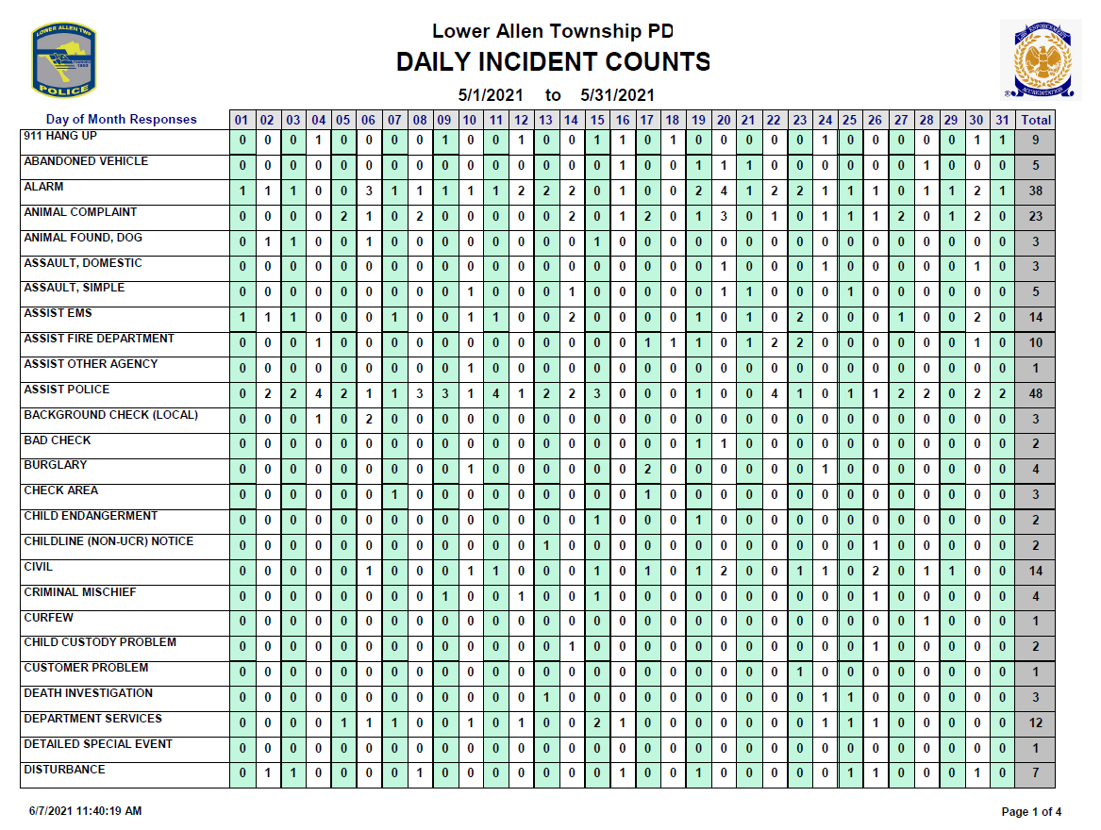

POLICE – MAY 2021
Operational Services Bureau
Lt. Douglas Foltz, Commander

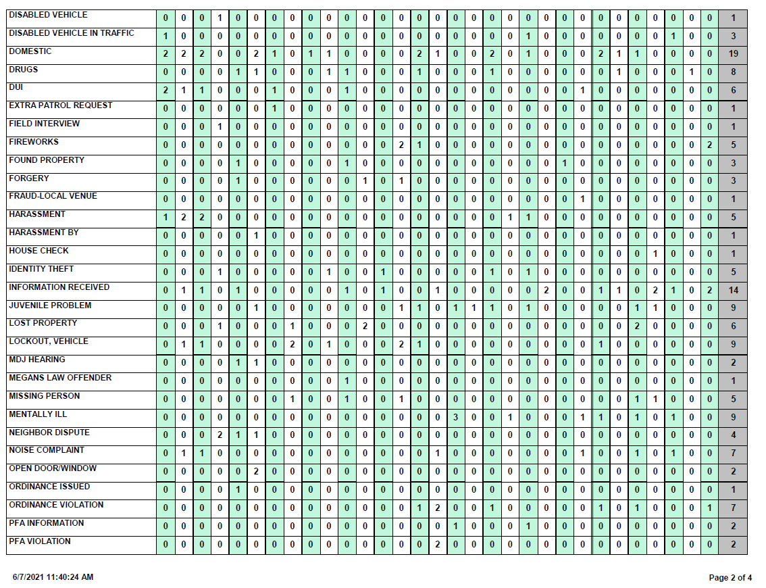

POLICE – MAY 2021
Operational Services Bureau
Lt. Douglas Foltz, Commander

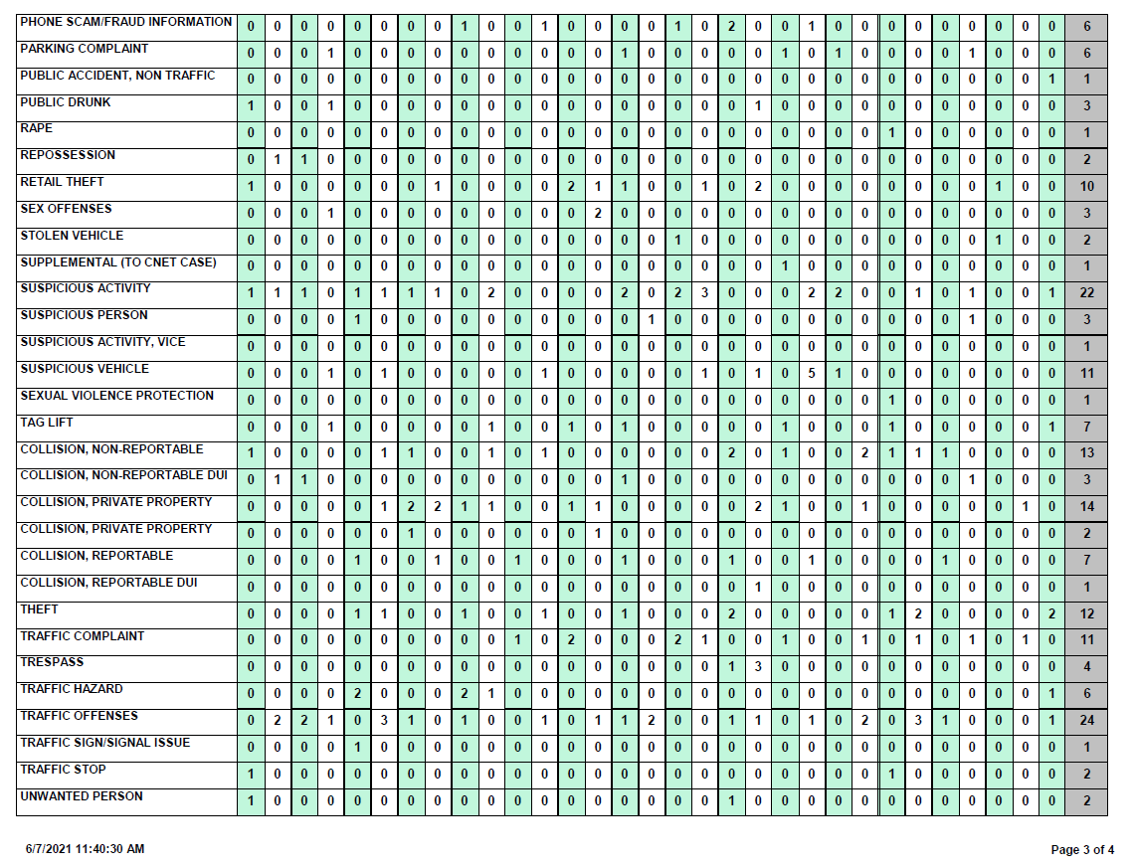
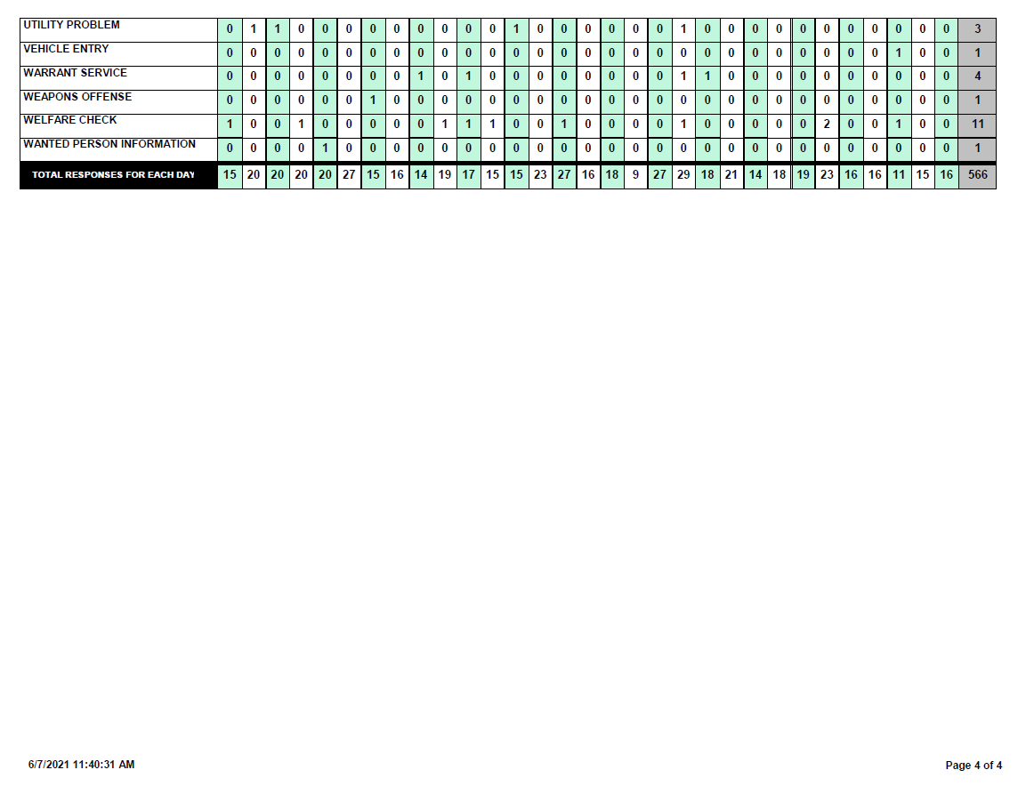
POLICE – MAY 2021
Operational Services Bureau
Lt. Douglas Foltz, Commander

Report prepared by:

Lt. Douglas L. Foltz
Bureau Commander of Operations

EMS – MAY 2021
Captain Tony Deaven
SUMMARY
The pre-hospital professionals in EMS continued providing excellent clinical care to the residents of Lower Allen Township. May was the first month since of March of 2019 that the number of COVID-19 patients treated and transported by LATEMS was in the single digits.

LATEMS worked tirelessly to ensure the residents of Lower Allen Township received the best clinical care possible while at the same time focusing on preventing the spread of COVID-19. LATEMS took unpresented steps to ensure PPE was obtained and supplies maintained for all divisions of public safety and for all departments in the Township. LATEMS went above and beyond all of its neighboring EMS services, to ensure the safety of the highest risk groups by initiating relationships and partnerships with the highest risk groups locations such as Bethany and The Woods.

LATEMS constantly focuses on the delivery of clinical care that exceeds minimum standards ensuring the best outcomes for the residents of the Lower Allen Township by developing standards of clinical care, which exceed the minimum standards established by the PA DOH. These standards of care were developed with considerable input and the approval of Dr. Modi. The standards focus on clinical care but are also fiscally responsible for the residents of Lower Allen Township. The updated clinical standards will be placed into effect in June.

The process of implementing the Hexagon Mobile responder application continued with the completion of education and hands on practice. The roll out of Hexagon Mobile responder application was successfully initiated as planned on May 19, 2021. Hexagon Mobile responder is new for Cumberland County Communications as well as the responders but the long-term benefits and enhancements to communications are mutually beneficial.

Lower Allen Township EMS will be hosting an Advanced Stroke Life Support class on August 20, 2021. The Advanced Stroke Life Support class is collaboration with Penn State Health System. The curriculum offers health care providers the training to make a rapid evaluation, stabilize, and care for stroke patients. Every 40 seconds, someone in the United States suffers from a stroke; and every 4 minutes, some dies. Having the skills to administer emergency care during the “golden window” of time improves the patient’s survivability and prognosis. The curriculum was developed by the Gordon Center, and is widely used by hundreds of hospitals, fire rescue, ambulance and EMS systems, and educational institutions throughout the country and around the globe.

Executive Assistant Dianna Kinsley and Captain Deaven completed a grant offered by Highmark. If the grant is successful items currently in the capital budget would be removed. Captain Deaven and Executive Assistant Dianna Kinsley completed the required eligibly filing for LATEMS to become eligible for grants from the Office of the State Fire Commissioner. These grants are available to Fire and EMS departments throughout the commonwealth.

Captain Deaven held an Emergency Vehicle Driver Training class for personnel from Lower Allen Fire Department, Lisburn Fire Department and Shiremanstown Fire Department. Captain Deaven also was the lead for a, FF down CPR course for the Lower Allen Fire Department and Shiremanstown Fire Department.

Captain Deaven participated in several Emergency Health Services Federation (EHSF), PA Bureau of EMS, Pennsylvania Emergency Health Services Council, Ambulance Association of Pennsylvania and Pennsylvania Fire and Emergency Services Institute meetings and education to ensure the continued development of the EMS system in Lower Allen Township.

EMS – MAY 2021
Captain Tony Deaven
SUMMARY

LATEMS continues to deliver high quality, effective, efficient, and safe patient care directly to the side of every patient in need of help. In May LATEMS touched the lives of 270 residents.

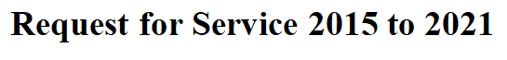

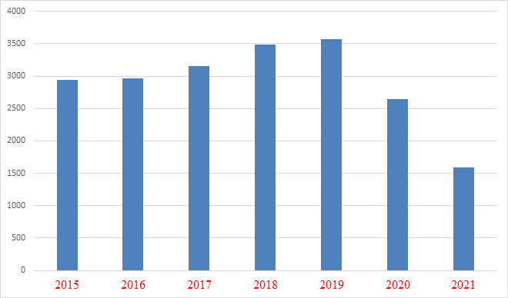

2015 | 2940
2016 | 2970
2017 | 3151
2018 | 3490
2019 | 3565
2020 | 2646
2021 | 1586

EMS – MAY 2021
Captain Tony Deaven
SUMMARY
Monthly Request for Service 2020 and 2021

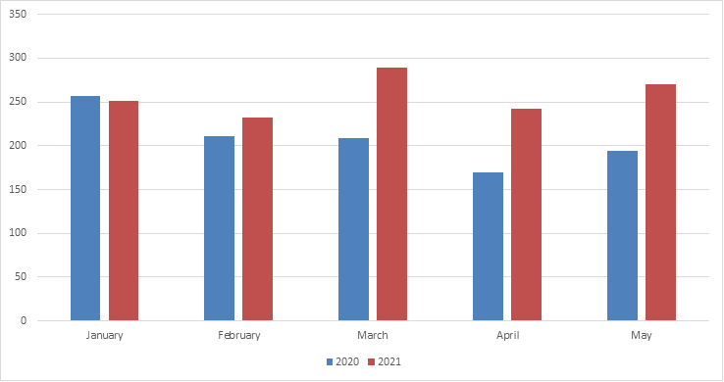 May-Request for Service by Day of the Week

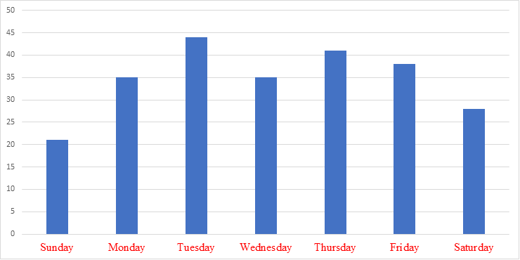
EMS – MAY 2021
Captain Tony Deaven
SUMMARY
May-Request for Service by Hour of Day

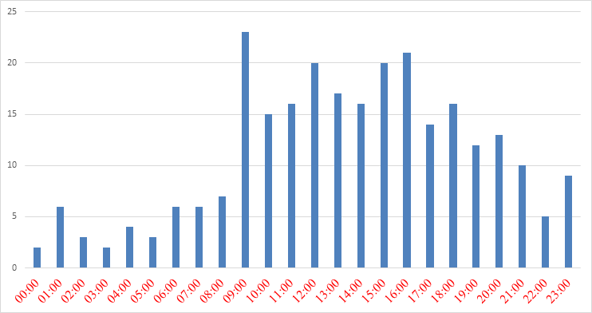
May-Mutual Aid Details

Mutual Aid Given | May
Camp Hill | 3
East Pennsboro | 2
Hampden | 8
Lemoyne | 6
Mechanicsburg | 3
Monroe | 0
New Cumberland | 0
Shiremanstown | 1
Silver Spring | 2
Upper Allen | 18
Wormleysburg | 0
York County | 6
Dauphin County | 0
Perry County | 0
Cancellations | 10
Other non-revenue | 6
Revenue | 33
Mutual Aid Given | 49
EMS – MAY 2021
Captain Tony Deaven
SUMMARY

May-Call Disposition

Assist, Agency | 8
Assist, Public | 3
Cancelled | 26
Patient Dead on Scene - No Resuscitation Attempted (Without Transport) | 1
Patient Treated, Released (per protocol) | 33
Standby - Public Safety, Fire, or EMS Operational Support Provided | 4
Transported Lights/Siren | 2
Transported No Lights/Siren | 193

Primary Injuries-January 1, 2021, to May 31, 2021

Animal/Plant Contact | 1
Assault | 11
Falls | 206
Firearms | 1
Intentional Self Harm | 3
Machinery Accidents | 2
Motorized Vehicle Accident | 46
Non-Motorized Vehicle Accident | 1
Pedestrian - Vehicle Accident | 2
Physical Exertion | 7
Poisoning | 1
Sharp Objects | 6
Struck by Object | 3
Suffocation/Asphyxiation | 1

EMS – MAY 2021
Captain Tony Deaven
SUMMARY
May-Primary Impressions
(Primary impressions are based on the provider’s impression of a patient after assessment)

Abdominal Pain | 19 |  | Hypertension | 2
Acute Pain, not elsewhere classified | 2 |  | Hypotension | 1
Acute Respiratory Distress (Dyspnea) | 7 |  | Infectious Disease | 1
Alcohol use | 1 |  | Injury | 14
Allergic Reaction | 4 |  | Injury of Face | 2
Altered Mental Status | 8 |  | Injury of Head | 13
Anxiety reaction/Emotional upset | 4 |  | Injury of Lower Leg | 2
Back Pain | 11 |  | Injury of Neck | 3
Behavioral/psychiatric episode | 4 |  | Injury of Shoulder or Upper Arm | 4
Cancer | 1 |  | Injury of Wrist, Hand, or Fingers | 2
Cardiac arrhythmia/dysrhythmia | 4 |  | Malaise | 10
Chest Pain / Discomfort | 12 |  | Mental disorder | 2
Chest Pain, Other (Non-Cardiac) | 1 |  | Nausea | 2
Chronic Obstructive Pulmonary Disease (COPD) | 1 |  | Obesity | 1
Confusion/Delirium | 1 |  | Obvious Death | 1
Congestive heart failure (CHF) | 1 |  | Opioid related disorders | 1
Constipation | 1 |  | Other | 21
COVID-19 - Confirmed by testing | 3 |  | Overdose - Alcohol | 1
COVID-19 - Suspected - no known exposure | 3 |  | Overdose - Unspecified | 2
Diabetic Hyperglycemia | 3 |  | Pain (Non-Traumatic) | 8
Diarrhea | 1 |  | Pelvic and Perineal Pain | 1
Dizziness | 4 |  | Respiratory disorder | 1
Dysphagia | 1 |  | Seizures | 3
Edema | 1 |  | Sepsis/Septicemia | 4
Esophageal obstruction | 1 |  | Shortness of breath | 5
Extremity Pain | 2 |  | ST elevation (STEMI) myocardial infarction of inferior wall | 1
Eye Injury | 1 |  | Stroke | 8
Fatigue | 3 |  | Syncope / Fainting | 7
Fever | 3 |  | Transient Cerebral Ischemic Attack (TIA) | 1
Foreign Body in Genitourinary Tract, Part Unspecified | 1 |  | Unconscious | 1
Gastro-Esophageal reflux disease (GERD) | 1 |  | Urinary Tract Infection (UTI) | 2
Gastrointestinal hemorrhage | 2
Headache | 3
Hemorrhage | 2
EMS – MAY 2021
Captain Tony Deaven
SUMMARY

Medication Administration
January 1, 2021, to May 31, 2021

Acetaminophen | 1
Adenosine | 1
Albuterol | 10
Aspirin | 25
Benadryl | 4
Cardizem Infusion | 1
Dextrose 10% | 6
Duoneb | 11
Epinephrine 1:1 | 6
Epinephrine 1:10 | 11
Fentanyl | 4
Glucagon | 1
Morphine | 1
Narcan | 1
Nitro Paste | 1
Nitroglycerin | 35
Ondansetron | 9
Solu-Medrol | 7
Terbutaline | 2
Tylenol | 1
Valium | 2
Versed | 2
Zofran | 19

EMS – MAY 2021
Captain Tony Deaven
SUMMARY

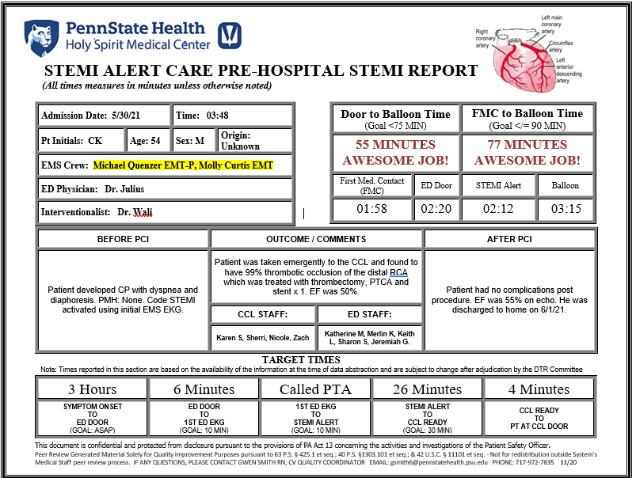

Fire Companies:
FIRE & PSOs – MAY 2021
Captain Frank Wirth
Statistics:
Lower Allen Fire Company
Building Investigations/Fires – 16
Vehicle Fires – 3
Automatic Fire/CO Alarms – 19
Automobile Accidents – 11
Other Emergency Incidents – 7
Service Calls/Transfers - 3
Total - 59
Automatic/Mutual Aid – 21

Lisburn Community Fire Company
Building Investigations/Fires – 3
Vehicle Fires – 0
Automatic Fire/CO Alarms – 1
Automobile Accidents – 3
Other Emergency Incidents – 1
Service Calls/Transfers/Fire Police - 0
Total - 8
Automatic/Mutual Aid – 7

Lower Allen Fire Company, Lisburn Community Fire Company, and Public Safety personnel attended the following training:

- On 5/4/2021 and 5/11/2021 HACC Instructor Tom Rigling conducted the last two sessions of a Pump Operations I class at Lower Allen Fire Station #1. The class was also attended by members of Shiremanstown Fire Company. This is a 16-hour state certificate class.
- On 5/9/2021 Lower Allen Firefighters Katrina Homovich, Shane Gaydos, and Lisburn Firefighter Michael Patrick completed their Interior Firefighter Training.
- On 5/18/2021 Public Safety Fire Captain Frank Wirth conducted a training session on Foam Firefighting Operations at the Lisburn Fire Station.
- On 5/19/2021 Lower Allen Fire hosted a class on Ropes and Knots at Lower Allen Fire Station #1.
- On 5/25/2021 Captain Bryce Landis conducted a training session on Engine Company Operations and Hoseline Management at the Lisburn Fire Station.
- On 5/26/2021 Lower Allen Fire hosted a training session on Downed Firefighter Procedures and EMS Captain Tony Deaven conducted a training session on CPR/AED.
- On 5/30/2021 Public Safety Fire Captain Frank Wirth started the Leadership in Supervision class at the National Fire Academy in Emmitsburg, MD.
- During the month of May EMS Captain Tony Deaven conducted the final session of an Emergency Vehicle Operations class at Lower Allen Township Public Works Garage on various dates as students were available to complete the driving course.

(The Officers of the Lower Allen Fire Company have opened their training program to neighboring fire departments. Shiremanstown Fire Company has taken advantage of this opportunity and has been consistently attending training sessions.)
FIRE & PSOs – MAY 2021
Captain Frank Wirth
Events/Activities:

The Lower Allen Township Department of Public Safety has resumed all car seat inspections/installs, smoke alarm installs, fire extinguisher training, and fire prevention presentations while practicing COVID-19 safety precautions.
The Lower Allen Township Department of Public Safety has resumed all Fire Inspections and Property Maintenance Inspections while practicing COVID-19 safety precautions.
The Lower Allen Township Department of Public Safety is continuing 24/7 PSO Coverage to ensure consistent Fire Apparatus Driver/Operator coverage during the COVID-19 pandemic.

On 5/10/2021 Lower Allen Fire, Police and EMS personnel participated in walkthroughs of the New Rossmoyne Elementary School at 2 PM and 7 PM. The walkthrough provided valuable information on the layout of the school, entrances/exits, and special features of the building.

On 5/10/2021 at the Lower Allen Board of Commissioners meeting PSO Bryce Landis was recognized by the Mechanicsburg VFW Memorial Post 6704 from the VFW National Level as a distinguished firefighter and EMT.
On 5/14/2021, and 5/28/2021 a meeting was conducted on the Alpine RedNMX Software Implementation Project for Lower Allen Fire Company, Lisburn Fire Company, Lower Allen Public Safety, and Lower Allen Fire Codes with the following invited to attend: Public Safety Director Dave Holl, LAFC Fire Chief Dave Murdoch, LCFC Fire Chief Frank Williamson, LAFC Assistant Chief Chris Trace, Fire Captain Frank Wirth, Fire Inspector Bill Yeagley, and PSO Bryce Landis. Currently projects are addressing issues with the Responder App and NFIRS downloading of data from the County Dispatch Center due to the change in the Computer Aided Dispatch program.

On 5/15/2021 Lower Allen Fire Company held a Chicken BBQ, which was very well received and very successful. All chickens were sold out.

On 5/19/2021 Public Safety Fire Captain Frank Wirth, EMS Captain Tony Deaven, and Public Safety Director Dave Holl met with Scott Ryno from Keystone Community Medical Services to discuss preliminary findings of the Public Safety Facilities Study.

On 5/21/2021 Public Safety Fire Captain Frank Wirth met with Tyler Rotelle, a prospective Live-In candidate and provided him with a tour of the fire station and discussed the College Tuition Reimbursement program and the expectations of being a Live-In firefighter at Lower Allen Fire.

On 5/28/2021 Public Safety Fire Captain Frank Wirth and PSO Bryce Landis met with Henri Lively and Brian Railing at Bethany Village West to discuss Pre-Planning of their facility.

On 5/29/2021 Public Safety Fire Captain Frank Wirth met with Dave Williams, a prospective Live-In candidate and provided him with a tour of the fire station and discussed the College Tuition Reimbursement program and the expectations of being a Live-In firefighter at Lower Allen Fire.

FIRE & PSOs – MAY 2021
Captain Frank Wirth
Public Safety Officers/Fire Captain/Fire Inspector:

Fire Department Responses:
Fire Captain - 20
Codes Coordinator/Fire Inspector - 19
Public Safety Officers – 91

Statistics:
Assist to Police Department – 1
Assist to Emergency Medical Services – 1
Child Safety Seat – 5
Fire Prevention Activities – 0
Fire Inspections – 15
Fire Permits Issued – 12
New Property Maintenance Cases - 20
Property Maintenance Inspections – 35
Property Maintenance Citations Issued – 0

Daylight Training Sessions:
5/6/2021 – PSO Justin Kettering, PSO Tom Kidd, and Fire Captain Frank Wirth participated in a webinar of NFPA 25 and NFPA 13 familiarization, which discussed sprinkler system installation, testing, and maintenance.

Other Training/Events:
On 5/24/2021 Justin Lenker started working as a Full-Time Public Safety Officer. He completed his EMS orientation in the last week of May.

PSO Eric Bowmaster is conducting Driver/Operator Training on Engine 1-12.

Incidents:

On 5/19/2021 in the early morning Lower Allen Fire Company responded to 500 Geneva Drive, Apartment 1A, in Upper Allen Township for a Bedroom Fire. Squad 12 responded and assisted with salvage and overhaul. The occupant was removed from the structure with minor burns to his hands. There was moderate fire and water damage to structure.

Live-In Firefighter Activities:

- Firefighter Brian Petkash responded to 28 (47%) Incidents during the month.
- Firefighter Patrick Dudzinski responded to 30 (51%) Incidents during the month.
- Firefighter Joshua Amberman responded to 19 (32%) Incidents during the month. (Off on Summer Vacation)
- Firefighters Brian Petkash and Patrick Dudzinski completed their Emergency Medical Technician Class. They now move onto completing the certification testing processes.
- On 5/26/2021 Firefighter Brian Petkash completed his qualification requirements to be a driver/Operator on Engine 3-12.

